TECHNEWS WEBSITE

1.HOME PAGE SECTION



2.TOP STORIES SECTION



3.LATEST NEWS SECTION

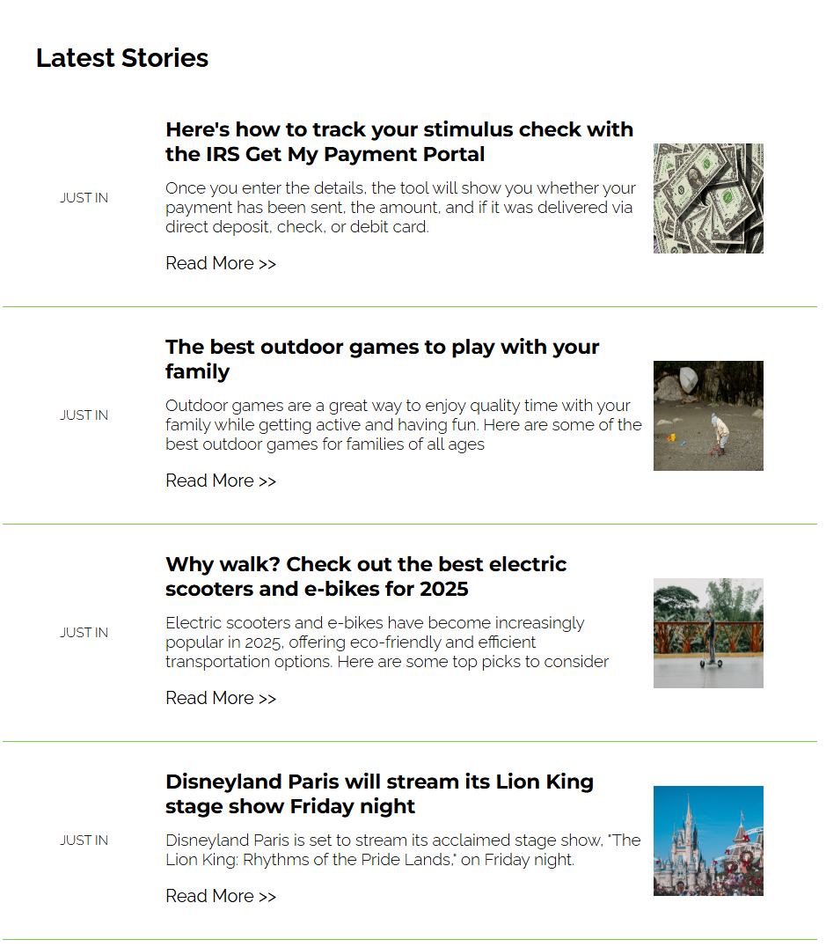

4.NAVIGATION BAR SECTION



5.FOOTER SECTION



6.NEWS LETTER SECTION

